**Practical No. 8**

1. **Design a program for creating a machine which**

**accepts string having equal no. of 1’s and 0’s.**

**Code:**

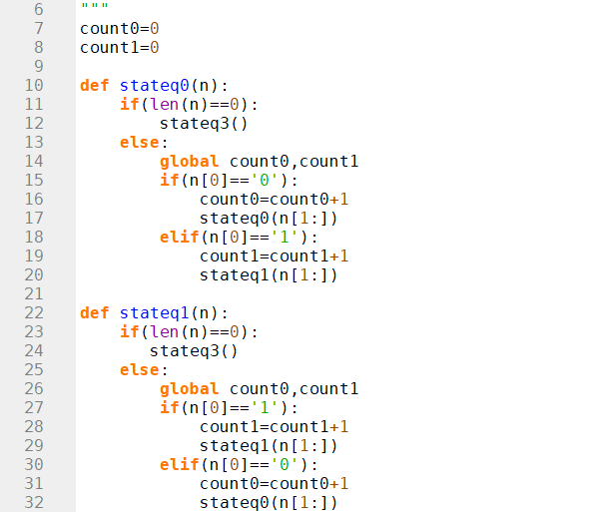

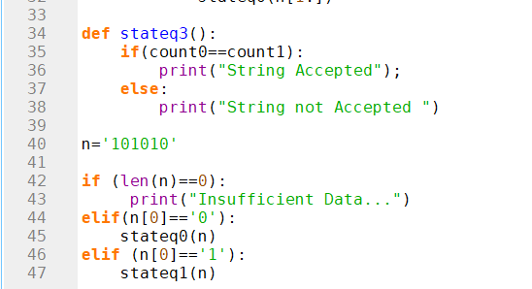

**Output:**

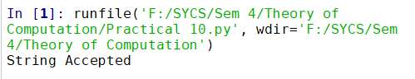

**Code:**

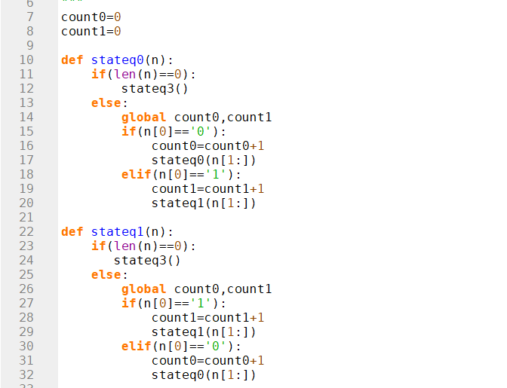

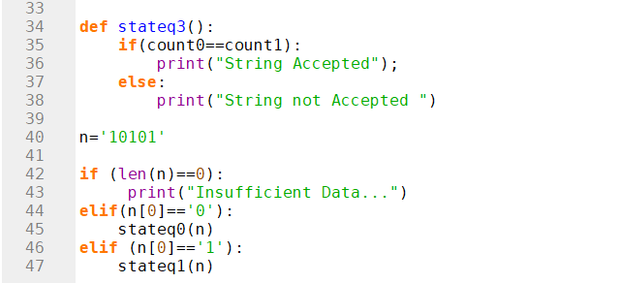

**Output:**

